StickEarn Data Engineer Technical Test
Name : Kemas Muhammad Adnan Fakhri Sjaf Fawwaz
- Part 1 : Architecture and Pipeline Design
  - System Design :
For the system design I use approaches such as medallion architecture and the ingestion method that I would choose is using Apache Airflow for the Orchestration and Clickhouse GCS table function. The pipeline start from Google Cloud Storage/On-premise MinIO to Airflow that act as orchestration tool. In the Airflow DAG, I use Clickhouse GCS table function for inserting the data to raw table in Clickhouse. In the raw table I use ReplicatedMergeTree engine because we can ensure high availability, fault tolerance, and automatic recovery which is critical for a 500million events/day data. I also defined the table partition by date for daily partitioning and order by device_id and timestamp. For deduplication problem, we can handle it within the MV before the cleaned table so the raw table can focus on availability data.
For the next step I use materialized view for data validation and cleaning. The process is divided into two conditions, first if the data is invalid then it will be loaded into the rejected table that contains noisy pings and impossible travel speeds. Second, if the data is valid then the data will be cleaned and loaded into cleaned table. After we have the clean data, there will be another materialized view for data aggregation that businesses needs and will be stored to data mart. The flow is depicted with the image below.
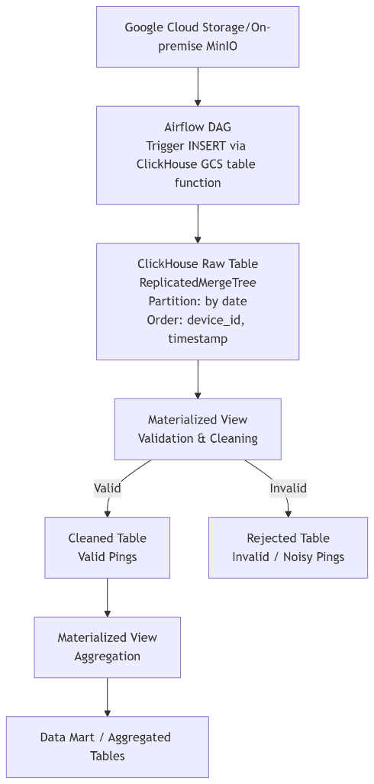

  - Data Quality
To ensure the geospatial integrity of the upcoming data, I will place the automated checks in the Materialized View before the Cleaned Table that will be automatically accept or reject data based on the validation terms.
- First, to check and ensure the ping is located in Indonesia, I use bounding box approach which filter the latitude between -11 and 6, and longitude between 95 and 144.
- Second, for the horizontal accuracy value that we can estimate the threshold. The threshold is defined with 15 meter, any value that exceeds 15 meter is categorized as noisy pings.
- Last by not least, we want to check and filter out exhibit impossible travel speeds. In automated check I use greatCircleDistance() function in Clickhouse to calculate the distance between two points and use it to calculate the speed from distance divide by time. We get the time by calculating the lag between two points. Final part is we filter out the speed that exceed 83 m/s or 300 km/hour that seems impossible to do.

- Part 2 : Clickhouse Implementation & Optimization
- 2.2 Performance Tuning
  - Deduplication
For handling the deduplication problem, I use medallion architecture approach, where the raw data stored in bronze layer (raw data table) and automatically processed using materialized view, then stored in silver layer (cleaned data table). The materialized view also stores the duplicate data in a rejected table in case there is a need for data auditing. The cleaned data table use ReplicatedReplacingMergeTree to handle deduplication while also maintaining replication across nodes.
  - Aggregations
For pre-calculating daily unique device counts per Kecamatan in Jakarta I would use Materialized View (MV) after the data being cleaned and stored in silver layer. The data then automatically processed using MV and stored in gold layer, where the data is ready and customized based on analytics needs.

